 Notes:
- Exact tab placement and other layout are naturally subject to change as we progress through beta feedback. Please remain resourceful when looking for visual items that may have shifted slightly since these screenshots were taken.
- If in doubt about a button or icon’s functionality, try hovering the mouse over the item to see if there’s a popup tip (aka “tooltip”) which offers some clarification.
- The test scripts at the end refer to the following screen shots…

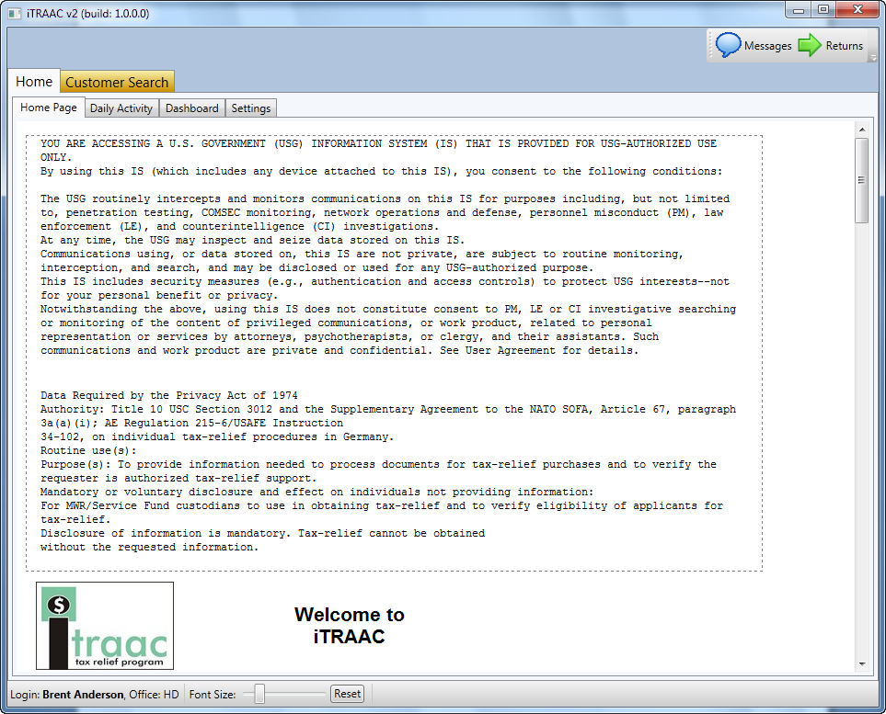
Figure 1 - Home Page

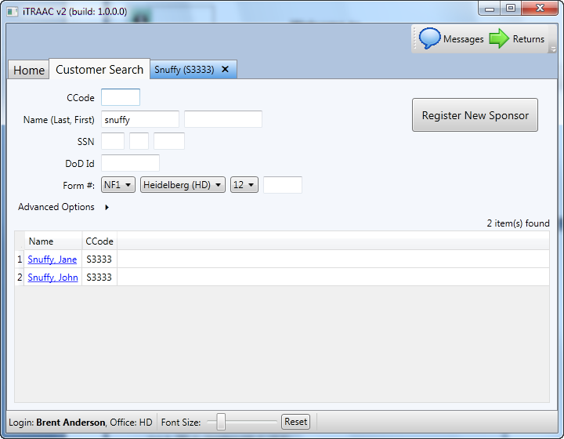
Figure 2 - Customer Search

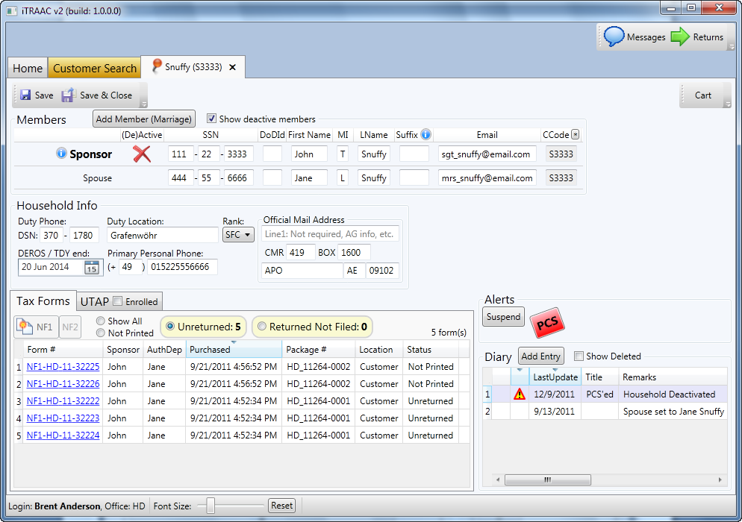
Hidden actions sButtons
Figure 3 - Customer Screen (aka Household)
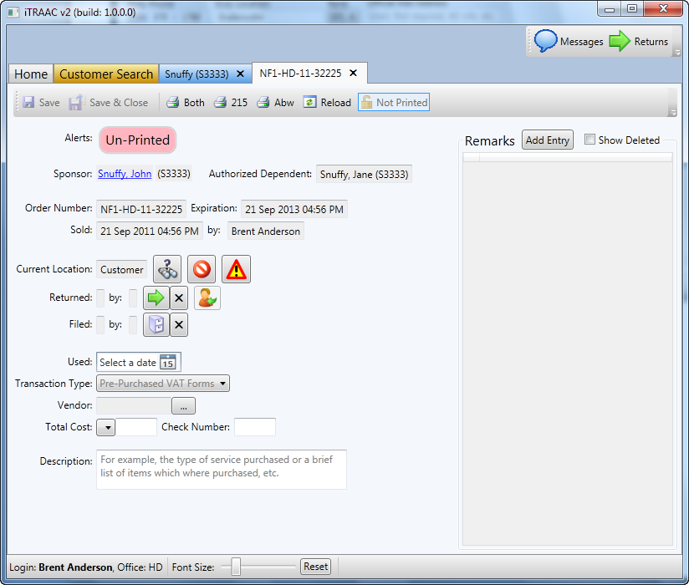
Figure 4 - Order Form Screen
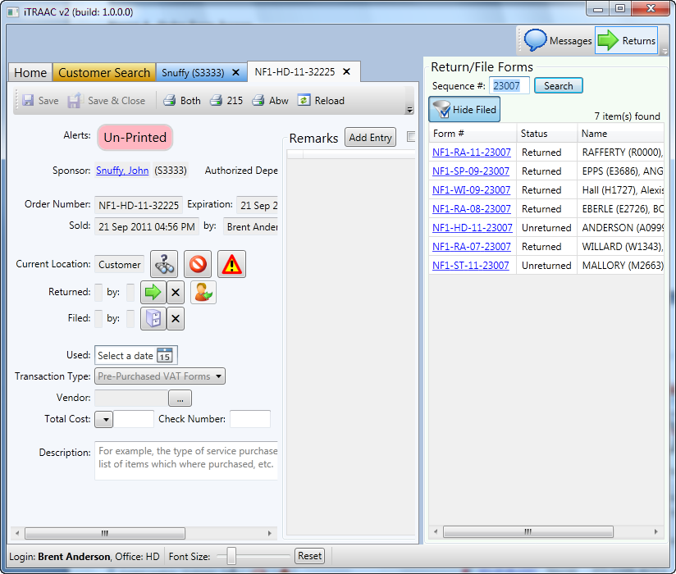
Figure 5 - Returns Popout Window

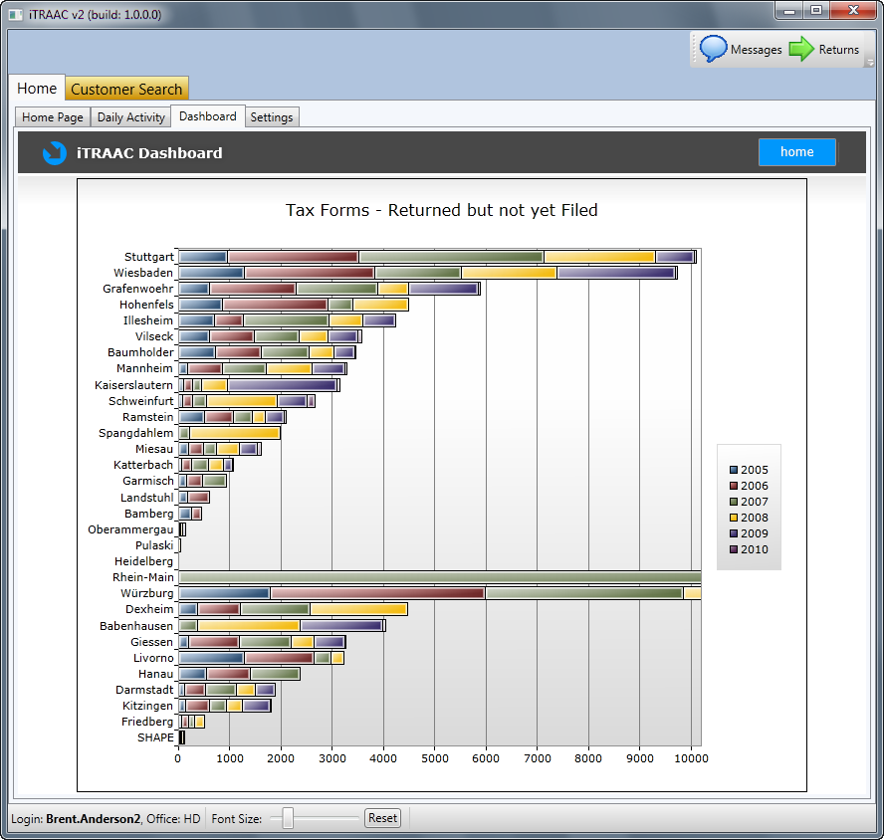
Figure 6 – “Dashboard” / Reporting Area (e.g. Forms Returned but not yet Filed)
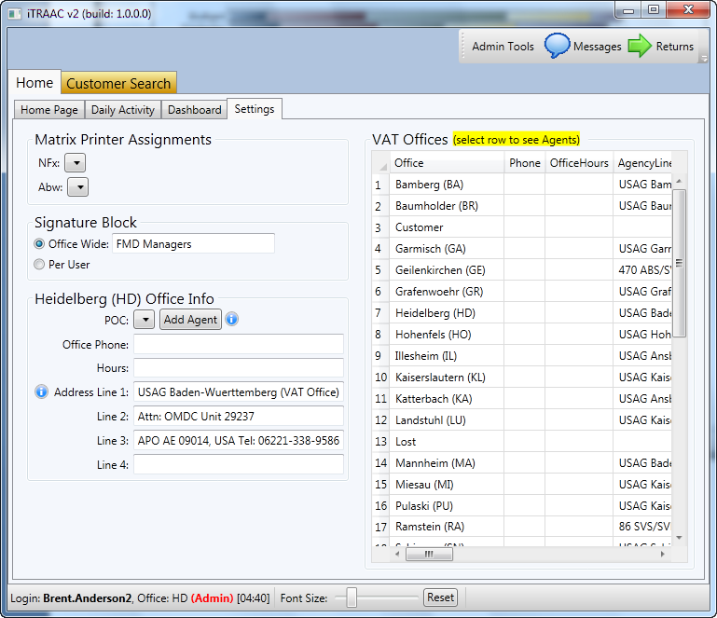
Figure 7 - Settings Page

Task | v2 Approach

Simple tasks
- Add New VAT Agent  (Admin only)  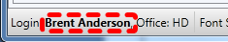  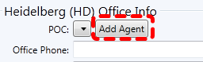 | Enter admin mode by double clicking your login name in the status bar at bottom-left of screen (fig.1). Navigate to Home tab > Settings tab, hit [Add Agent] button under Office Info (fig.7).  TODOs:  - The new user’s login name must coincide with an active Windows account or iTRAAC won’t allow access… in ideal world, this list of users would be maintained in the new EURMWR Domain, for now we’ll have to manage them on each VAT workstation… this does have the implication of making it more annoying for people to jump between multiple workstations… i.e. the generic POSUser account cannot be used anymore, I believe this is a good thing from a security standpoint  - Probably need to display default login name formed by first+last name, but also allow for matching to an existing Windows account.  - Slickest way would be to prompt “Create Windows Account?”, prompt for local admin credentials, and automatically create (or verify already exists)… otherwise admin just has a little more manual work to do, not the end of world.  - This also has conversion implications for existing users… probably ideally we’d have a script (powershell??) that takes the active iTRAAC v1 users and creates local Windows accounts for them… I guess the existing naming convention is good enough  - Just in case this new user ever needs to fall back to v1, these logins can be readily activated in via v1’s [reset password] button.
- Sell New Forms  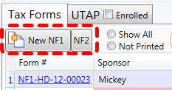 | Search for & open customer (fig.2)  See NF1/NF2 buttons in lower left (fig.3)

- Return/File Form  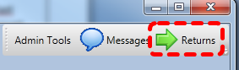  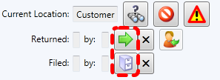 | Open Returns window (fig.5)  enter form#  select form to open from list  -OR-  Search & open customer  select form to open from lower left grid (fig.3)  then hit the Return (green right arrow) or File (filing cabinet) buttons (fig.4)  TO DO: document the procedural changes surrounding Transaction Type vs. Goods and Services… here’s some starter verbiage…  . Rafeal wasn't really that interested in the Goods & services data... it was too specific... there's too many of them... he basically needs forms bundled into higher level categories to run any meaningful reports...  . So he likes the list of transaction types much better... especially after he took the time to clean up the list and consolidate a couple (as you can see from the greyed out ones in the dropdown)... in Raf's opinion, everything that was a good/service should fall into a very obvious higher level transaction type.  . There's no more free form adding of Goods/Services to deal with... Rafael defines the static list of TxnTypes that he wants to be chosen from and that's it.  . So basically we're just swapping Transaction types in as required field for NF1's as well now and dropping Goods/Services across the board... TxnTypes is a short list (<30) so we're hoping??? it's that much more fast and obvious to select one than Goods/Services.  . The free form description is not required ... I realize that probably means we won't get much info there... but it's available if need be.  TO DO – weapon/vehicle field bug fix  . When you select weapon or vehicle, those specific additional fields will show up and be required... basically like before but a little more organized than throwing them into the rest of the remarks... hmmm... that part is broken at them moment... Another bug fix on my list... will let you know when you can check that out.
- Lost Form  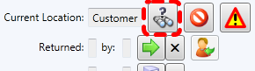 | (fig.5) Click . Form location will change to LOST. The lost forms memo will pop up, prepopulated with the basics.
- Create New Account  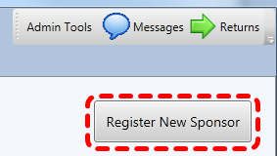 | Customer search screen (fig.2) => [Register New Sponsor] button.  Duplicate Check - As the new customer name and SSN/DoDId are entered, a background search will check if the customer already exists. If existing potential customer matches are found, they will be displayed in a grid to the right of the members list. Click on the customer name in this grid to open an existing customer record instead, and then simply close the empty new sponsor tab without saving.
- Add New Dependent  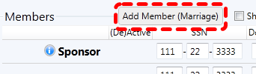 | Open customer  Hit [Add Member (Marriage)] button at the top of Members grid (fig.2).  Hidden Actions - Take a moment to discover the hidden house member action buttons (fig.3). Examples include: designating a Spouse and initiating Divorce procedures. Typically we don’t plan on hiding functionality but it was determined that these buttons were making the screen too busy from a typical usage standpoint.

More complex tasks
- Consolidating customer codes  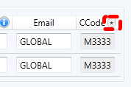 | (fig.3) The little [*] button next to the CCode column header will change all house member codes to be the same as the sponsor.  Over time the codes can get a little messy for example due to mis-keyed SSN’s and changing last names. We’ve often heard from the field that confusion can arise regarding which code should be provided when a customer comes into the tax office for service. This button makes it easy to say, “ok, now everyone in your family should use the same code.” Naturally, in order to prevent confusion, this should not be applied without informing the customer of the change.
- Marriage | (fig.3) Hit [Add Member (Marriage)] button at the top of Members grid.  Refer to the (5) regarding the duplicate check functionality that is in play here as well.
- Active/Deactive  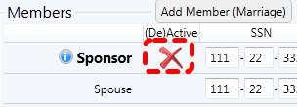 | (fig.3) The Sponsor’s de-active flag is now synonymous with the entire household to make things more consistent. When the household is deactive, no new forms can be sold.  Attempting to deactivate Spouse will prompt for proper divorce documentation and must be executed via the [Divorce] button  Deactivating a dependent is basically just a means to hide them from cluttering the list of members... it will also remove them from being listed on the Authorized Dependent choice when generating a new forms package.
- Divorce  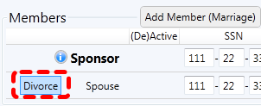 | (fig.3) Divorce simply deactivates the spouse. Deactivation hides the spouse from view and they won’t be printed on new forms.
- Name Change  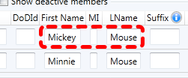 | (fig.3) Simply edit the name(s) in the members grid and save.  Background logic will determine if the name has changed significantly (e.g. due to Marriage) or if it is simply a typo fix. If it is a true name change, system will then stamp all existing forms to date with the *old* name to maintain proper paper trail. New forms will be generated with the new name.
- PCS’ing  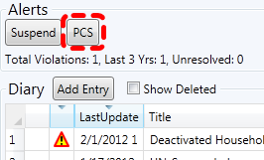 | (fig.3) PCS is now an explicit status that can be set. It will automatically deactivate the whole household.
- Suspension/Barring  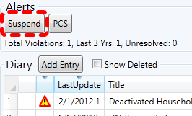 | (fig.3) There is now only the single concept of Suspension to keep things simple. Barring is represented by a suspension with no end date. While suspended, the whole household will be deactivated.
- Form Violation  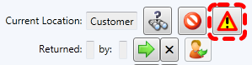 | (fig.4) Click . Enter violation reason.  - Also, attempting to file an NF1>2500 Euro will trigger an automatic violation event.  - Violation history will be listed in the Form remarks list as well as the Customer remarks list, lower left corner of fig.3  - Form Violations also now automatically generate a Customer Suspension event…  - This automatic customer suspension is left with an open end date to prompt Agents to address the circumstances and establish an appropriate suspension end date.  - The 3 strikes in 1yr count is also automatically maintained.
- Resolving Alerts  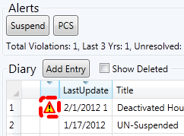 | (fig.3) UN-Checking Alerts will now prompt for a reason. This reason will be recorded in the AlertResolved field. This is a compromise to make alerts more manageable, yet still provide some trackability.
- Incomplete Form  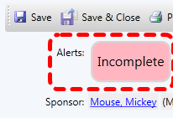 | - (fig.4) Attempting to File a form that doesn’t pass validation will now automatically set the form to incomplete status.  - NOTE: Incomplete forms now count against the customer’s 10 count.  - Incomplete forms will be highlighted in the list of forms on the corresponding customer tab as well to remind the Agent to give the incomplete forms back to the customer for correction when the customer next returns to the office…  - When this moment occurs, the Agent should use the  button to indicate the change in form location from office to customer.  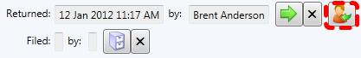
- Void Form  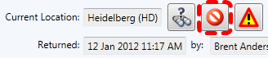 | - icon fig.4  - TODO: should prompt for encouraging agent to collect all copies of this form where possible.

